EFK INSTALLATION

ON EFK SERVER

Install Java 8

Add the Oracle Java PPA to apt:
sudo add-apt-repository -y ppa:webupd8team/java
Update your apt package database:
sudo apt-get update
sudo apt-get -y install oracle-java8-installer

Install Elasticsearch

Run the following command to import the Elasticsearch public GPG key into apt:
wget -qO - https://packages.elastic.co/GPG-KEY-elasticsearch | sudo apt-key add -
reate the Elasticsearch source list:

echo "deb http://packages.elastic.co/elasticsearch/2.x/debian stable main" | sudo tee -a /etc/apt/sources.list.d/elasticsearch-2.x.list

Update your apt package database:
sudo apt-get update
Install Elasticsearch with this command:
sudo apt-get -y install elasticsearch
Elasticsearch is now installed. Let's edit the configuration:
sudo vi /etc/elasticsearch/elasticsearch.yml

network.host:0.0.0.0
port : 9200

Save and exit elasticsearch.yml.
Now start Elasticsearch:
sudo service elasticsearch restart
Then run the following command to start Elasticsearch on boot up:
sudo update-rc.d elasticsearch defaults 95 10

Install Kibana
Kibana can be installed with a package manager by adding Elastic's package source list.
Create the Kibana source list:
echo "deb http://packages.elastic.co/kibana/4.4/debian stable main" | sudo tee -a /etc/apt/sources.list.d/kibana-4.4.x.list
Update your apt package database:
sudo apt-get update

Install Kibana with this command:
sudo apt-get install kibana
sudo nano /opt/kibana/config/kibana.yml

server.host: 0.0.0.0
server.port: 5601

sudo update-rc.d kibana defaults 96 9
sudo service kibana start

install apache2

and configure
curl -XGET http://localhost:9200

sudo nano /etc/apache2/conf-enabled/kibana.conf

<Directory /opt/kibana>
Order allow,deny
Allow from all
</Directory>

save and exit

There are main ways of running and installing elasticsearch-head

cd /usr/share/elasticsearch

install the head by

sudo elasticsearch/bin/plugin install mobz/elasticsearch-head

link https://github.com/mobz/elasticsearch-head

and check it by

http://server ip or local host/9200/

curl -XGET http://localhost:9200

by this command cluster name and all get

there will shows the version and all if not getting elastic search installation is not correct

plugin site

http://server ip or local host/9200/_plugin/head

then we can see indexes all information here

http://server ip or localhost:5601 is the kibana site we can create it

from index name from elasticsearch gui

for elastic search restart

/etc/init.d/elasticsearch restart

for kibana restart

/etc/init.d/kibana restart

ON CLIENT

install td-agent
curl -L https://toolbelt.treasuredata.com/sh/install-ubuntu-trusty-td-agent2.sh | sh
##install plgin
sudo /opt/td-agent/embedded/bin/fluent-gem install fluent-plugin-elasticsearch

nano /etc/td-agent/td-agent.conf
nano td-agent.conf

bizruntime@biz:~$ sudo cat /etc/td-agent/td-agent.conf
<source>
type tail
format none
# time_format %b %d %H:%M:%S %Y
pos_file /var/log/td-agent/syslog.pos
path /var/log/syslog
tag sys
</source>

<source>
type tail
format none
# time_format %b %d %H:%M:%S %Y
path /var/log/apache2/*.log
pos_file /var/log/td-agent/access.log.pos
read_from_head true
tag access1
</source>

<source>
type tail
format none
path /var/log/tomcat7/catalina.out
pos_file /var/log/td-agent/tomcat.pos
read_from_head true
tag tomcat
</source>

<match sys>
@type elasticsearch
host 192.168.1.235
port 9200
include_tag_key true
tag_key @log_name
user admin
password admin
index_name syslog
type_name syslog
logstash_prefix syslog
logstash_format true
flush_interval 10s
</match>

<match access1>
@type elasticsearch
host 192.168.1.235
port 9200
include_tag_key true
tag_key @log_name
user admin
password admin
index_name apachelog1
type_name apachelog1
logstash_prefix apachelog
logstash_format true
flush_interval 10s
</match>

<match tomcat>
@type elasticsearch
host 192.168.1.235
port 9200
include_tag_key true
tag_key @log_name
user admin
password admin
index_name tomcat
type_name tomcat
logstash_prefix tomcat
logstash_format true
flush_interval 10s
</match>

save and exit

here i created 3 logs indexes apache,syslog,tomcat
host 192.168.1.235 this one is the server ip

##check conf file is correct or not
td-agent -c td-agent.conf

when this command running position file content clear

create each log position file ie example
pos_file /var/log/td-agent/access.log.pos

and give permsiion 777 to that

link:
https://github.com/GoogleCloudPlatform/fluentd-catch-all-config/blob/master/configs/config.d/syslog.conf

on browser

take http://server ip or local host/9200/_plugin/head

and check whether the index is seen there

and take http://server ip or localhost:5601

and check and create gui log in kibana site with that indexes

ie syslog-* with timestamp
apachelog-* with timestamp
tomcat-* with timestamp

and check the logs are seen there for each indexes

install readonly plugin

for security installing read only plugin go

https://github.com/sscarduzio/elasticsearch-readonlyrest-plugin

in the INSTALL THE PLUGIN
there we can download with selecting each version
and the downloaded item is sent to the mail
we can downloaded from there

and we can give the security for each user and there logs that describe in the above link

in my elasticsearch.yml configuration

#check all the space and symbols

network.bind_host: 0
readonlyrest:
enable: true
response_if_req_forbidden: Forbidden by ReadonlyREST ES plugin
access_control_rules:
- name: "Elasticseaech can write and create its own indices"
# auth_key is good for testing, but replace it with `auth_key_sha1`!
auth_key: admin:admin
type: allow
actions: ro+
indices: ["tomcat-*","apachelog-*","<no-index>"]
- name: Admin Usage for Server (we trust this server side component, full access granted via HTTP authentication)
auth_key: admin:admin
type: allow
- name: apache Machine (This server side component, only access granted via HTTP authentication with below username password)
auth_key: apache:apache
type: allow
kibana_access: ro+
indices: [".kibana*","apachelog-*"]
- name: tomcat (This server side component, only access granted via HTTP authentication with below username password)
auth_key: tomcat:tomcat
type: allow
kibana_access: ro+
indices: [".kibana*","tomcat-*"]
- name: syslog (This server side component, only access granted via HTTP authentication with below username password)
auth_key: syslog:syslog
type: allow
kibana_access: ro
indices: [".kibana*","syslog-*"]

in the kibana.yml configuration

copy this in to last line

elasticsearch.username: "admin"
elasticsearch.password: "admin"

save end exit

restarts

/etc/init.d/elasticsearch restart
/etc/init.d/kibana restart

check http://server ip or localhost:5601

check each logs index with its username and password

the apache user and password only accessible for apache index logs
there is no permission for accessing the other logs

next is the creation of dashboard
eg: i forgot some terms here so search for this or ask anyone
take the site http://server ip or localhost:5601

and login as tomcat user and password

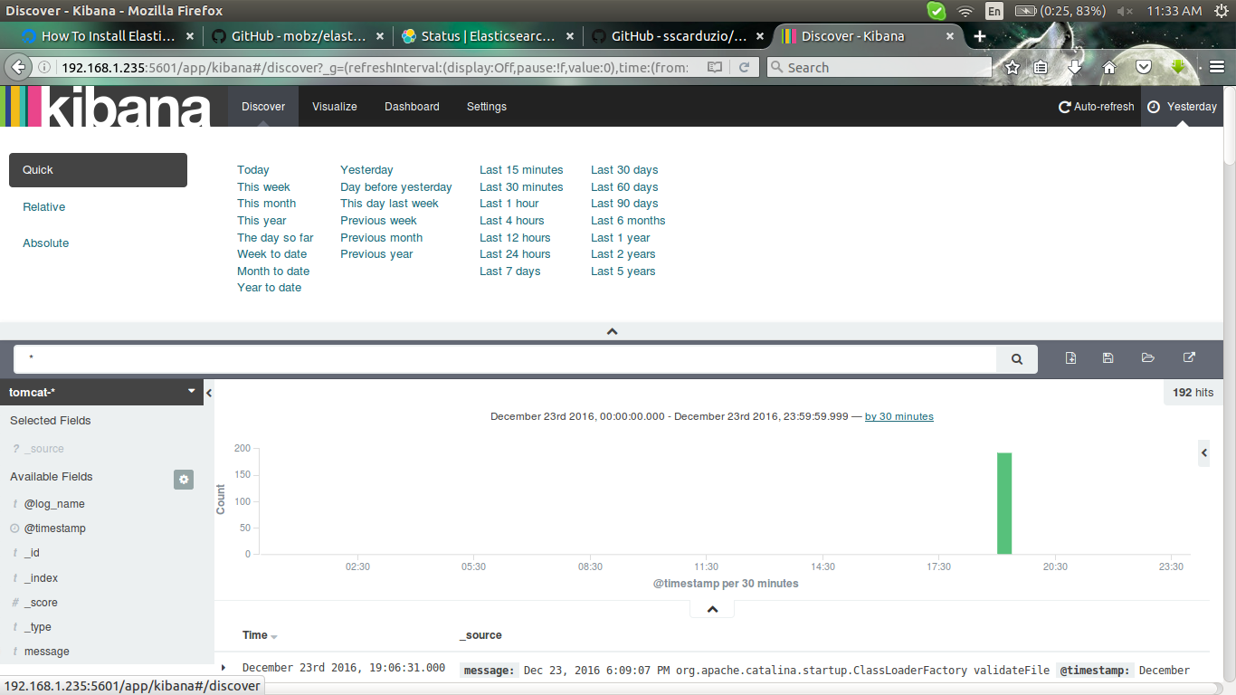

there we want to configure the discover portion visualize portion and dashboard portion

first discover portion

save it
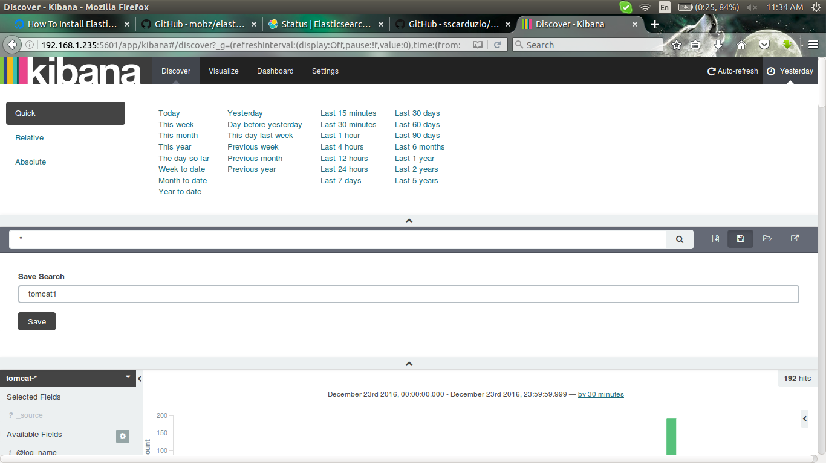

in the visualize
take vertical bar chart at down

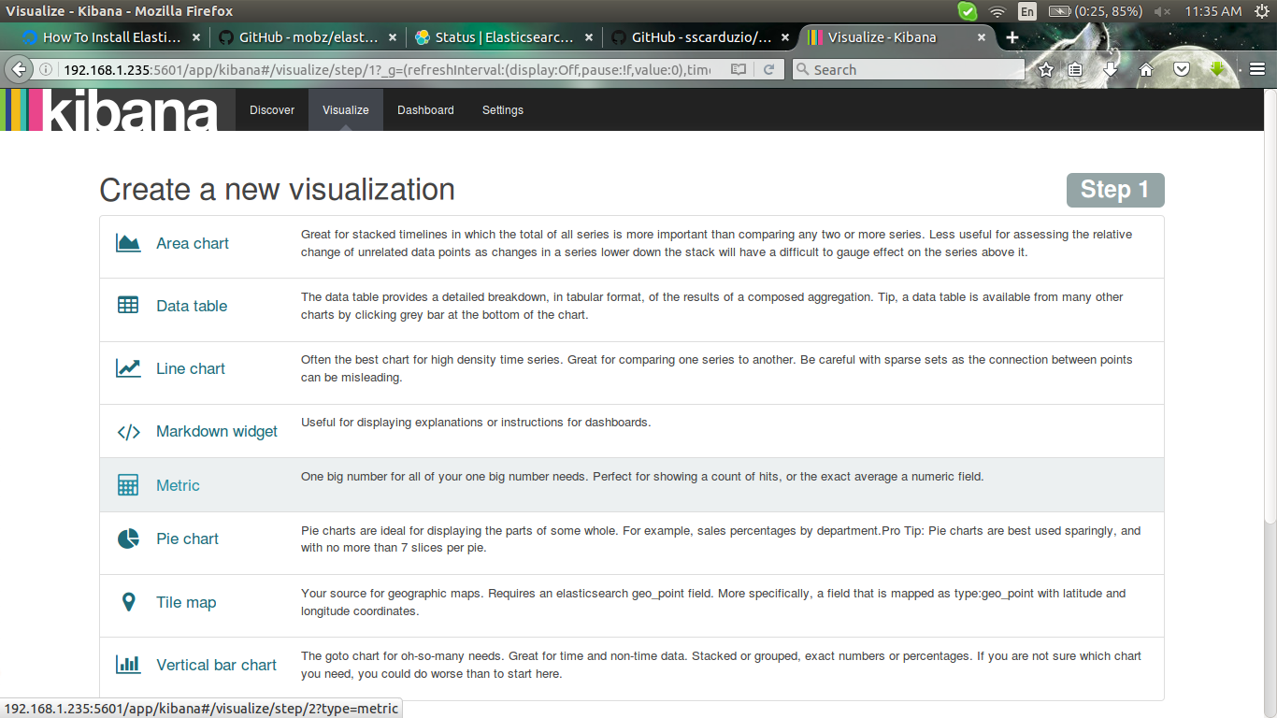

click new search
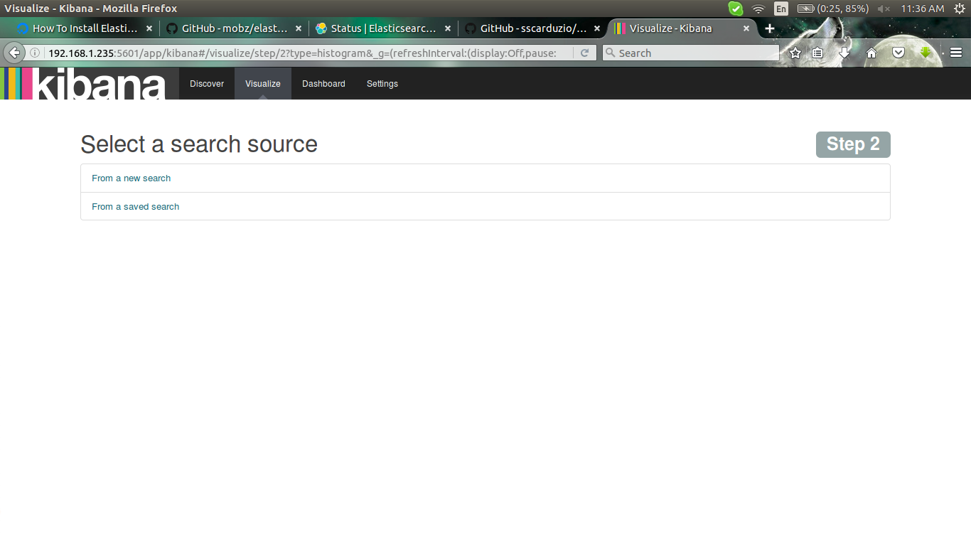

select the index pattern
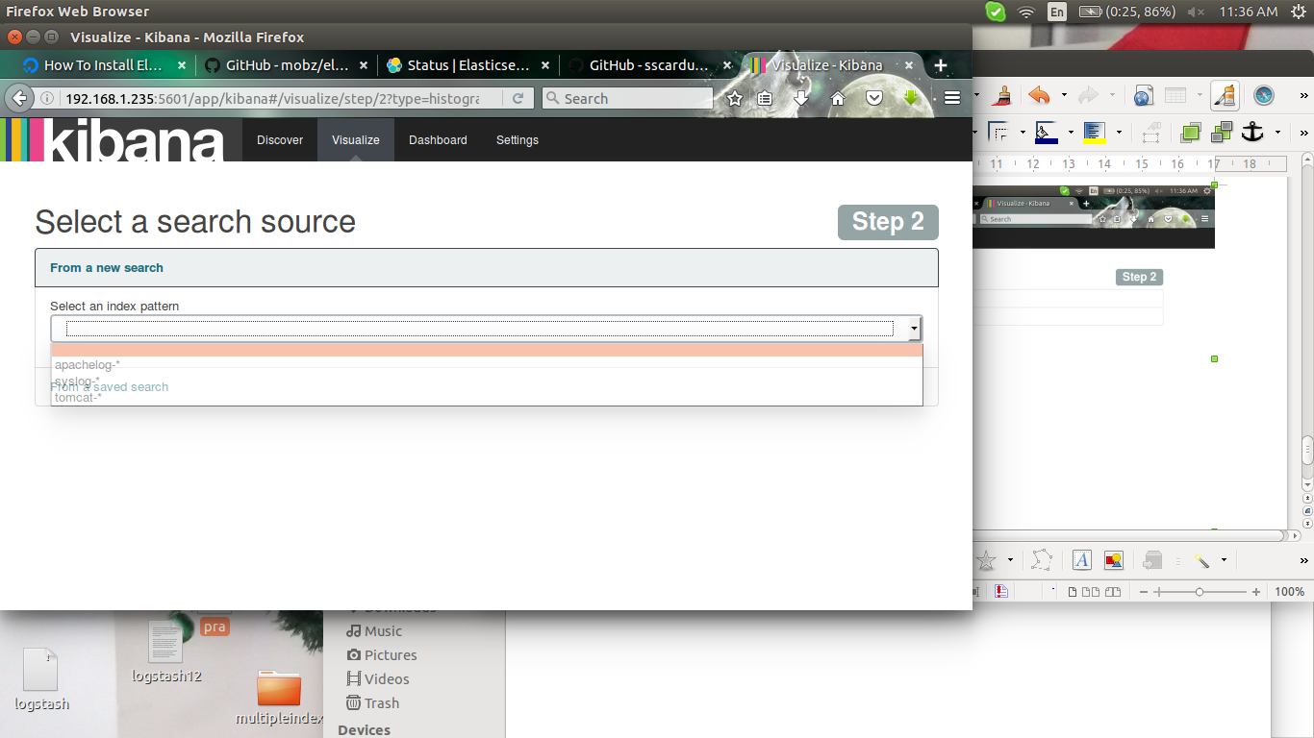

here tomcat

there will first selection of y axis
and aggregation in to terms
and select messages

then x axis
aggregation term
and next will timestamp
and save

next is dash boardselect the visualization name and selact the arrow

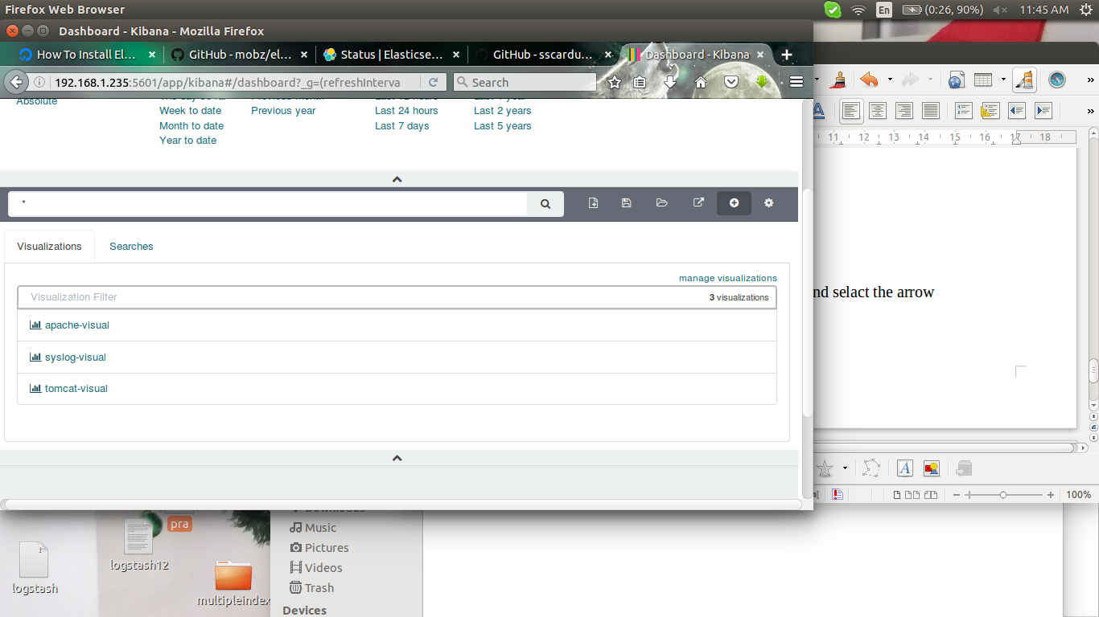

in the searches select the log before saved as tomcat1.logs

group based access control

- name: Accept requests from users in group team1 on index1
type: allow
groups: ["team1"]
kibana_access: ro
indices: [".kibana*","tomcat-*","apachelog-*"]

- name: Accept requests from users in group team2 on index2
type: allow
groups: ["team2"]
kibana_access: ro
indices: [".kibana*","syslog-*"]

users:

- username: user1
auth_key: user1:user1
groups: ["team1"]

- username: user2
auth_key: user2:user2
groups: ["team2", "team1"]

